Crawler Bot Reinforcement Learning
CPS 480
May 2, 2026
Grant Harvey
Overview
In this project, I implemented three reinforcement learning algorithms (Monte Carlo, TD SARSA, and Q-Learning) to train a crawler bot to move forward efficiently using its two-arm system. The goal was to learn a policy that maximizes forward movement by updating Q-values for each state-action.
Overall, the implementation works correctly and meets the project requirements. The crawler is able to explore different states, update its Q-values, and gradually improve its movement behavior.
What Worked Well
The implementation of ε-greedy action selection functioned correctly, balancing exploration and exploitation. With ε = 0.1, the agent explored new actions while still favoring the best-known ones. Adding random tie-breaking between equal Q-values improved exploration early in training and prevented the agent from getting stuck repeating a single action.
All three learning algorithms behaved as expected. Each followed its proper update rule and integrated well with the crawler environment, allowing the agent to gradually improve its movement over time.
What Didn’t Work Well
Learning was relatively slow due to the large state space (703 states × 9 actions). Many state-action pairs are rarely visited, which limits how quickly the agent can improve.
The reward function was too simple, relying only on forward movement. This caused inefficient behaviors since there was no penalty for wasted motion or instability.
Monte Carlo performance was also affected by inconsistent episode lengths (5–30 steps). Short episodes sometimes failed to provide enough information for meaningful updates.
Why I Initialized Q-Values to 0.1
I noticed how every one of my formulas took a lot of iterations to start showing growth, so I initialised all of the Q-values at a starting value of 0.1 and they all worked so much better. If all Q-values start at 0, the agent has no incentive to prefer unexplored actions over previously tried ones, which I think slowed down the learning.
Results
After running multiple learning iterations (1000+ steps), the agent begins to improve:
- Q-values start to vary across states and actions
- The agent explores more efficiently
- Movement becomes less random over time
- Monte Carlo is the slowest of the three from my testing
- Q-Learning is the fastest of the three from my testing
Monte Carlo Training Screenshot
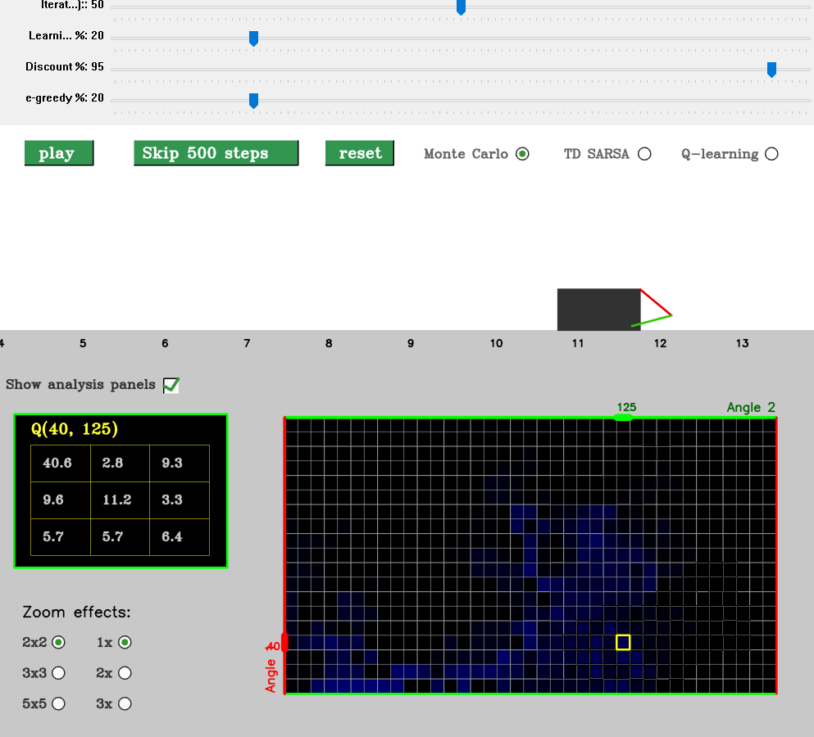
TD SARSA Training Screenshot
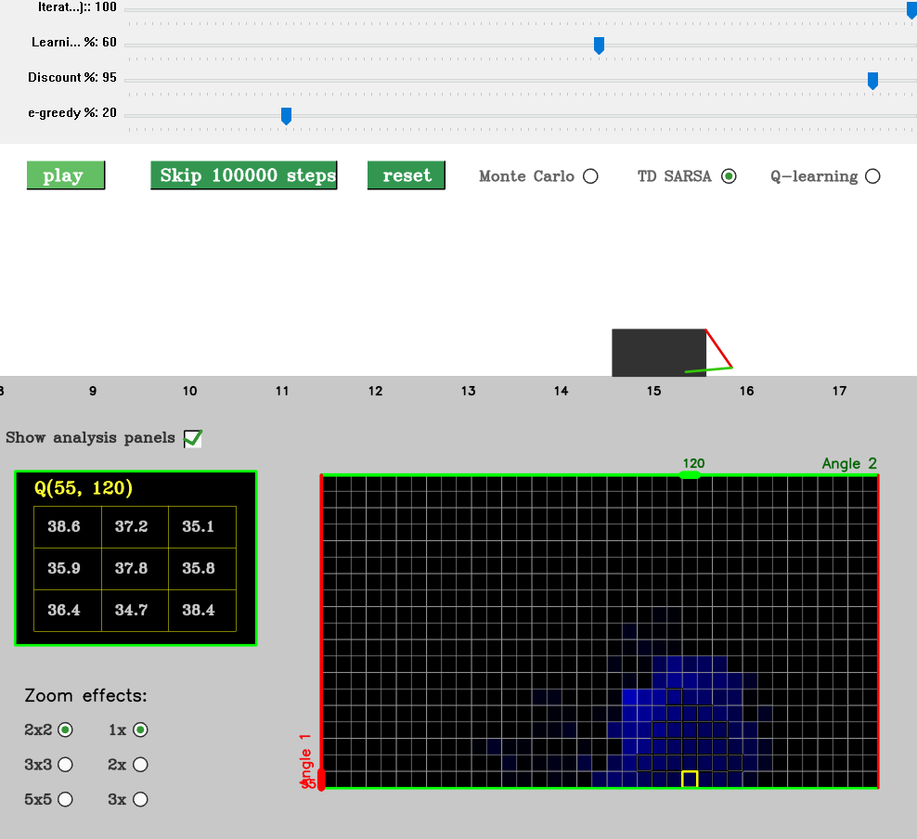
Q-Learning Training Screenshot
